Experiment No. 08
Digital Marketing Strategy and AI Tools for Business Promotion
A.1 Aim:
To plan, design, and evaluate a digital marketing strategy for a selected business idea using freely available social media, website, and AI tools for content creation, promotion, customer engagement, and market analysis.

PART B
(PART B: TO BE COMPLETED BY STUDENTS)
Experiment No.: 08

Name: Avdhut Parish Madhavi
Roll No.: C60
Class/Batch: SE-C2
Date of Experiment: ________________
Date of Submission: ________________
Business Idea: Navro Living’s
Grade: _____________________________

B.1 Observations and Learning
1. My Business Idea
NAVRO Living is a gardening service that transforms balconies, terraces, and rooftops into attractive green spaces. It provides garden design, plant selection, installation, and maintenance services. Its tagline is “New Beginnings. Greener Living.”
2. My Target Customers
- Age group: 22–50 years.
- Location: Urban and residential areas.
- Occupation: Working professionals, homeowners, and business owners.
- Interests: Gardening, home décor, plants, and sustainable living.
- Needs: Attractive green spaces, space-saving garden designs, and easy maintenance.
- Buying behaviour: Customers may discover services through Instagram, compare designs and prices, and contact the business online.
3. Digital Platforms Selected
Platform | Purpose
Instagram | Promote garden designs through Reels, posts, and stories.
WhatsApp Business | Communicate with customers and receive enquiries.
Website | Display services, brand information, and contact details.
Facebook | Reach local homeowners and residential communities.
4. AI Tools Used
Tool | Application
ChatGPT | Creating captions, advertisements, and post ideas.
Canva | Designing promotional posts and brand materials.
Gemini | Generating ideas and prompts for gardening promotional videos.
Instagram Insights | Analysing views and content performance.
5. Most Useful AI Application
ChatGPT was useful for generating Instagram captions, promotional ideas, and video concepts for NAVRO Living. Canva helped create professional brand visuals, while Instagram Insights helped evaluate the performance of published content.
6. Customer Feedback Received
The Instagram Insights screenshots collected for this experiment showed the following results:
Metric | Observed Result
Account views in the last 30 days | 128
Account viewers | 90
Views from non-followers | 100%
Views from Reels | 93.8%
Individual Reel views | 75
Individual Reel viewers | 67
Likes on the displayed Reel | 0
Comments on the displayed Reel | 0
Observation: Reels were the main source of visibility, and all recorded account views came from non-followers. However, the displayed Reel had no likes or comments, indicating that engagement needs improvement.
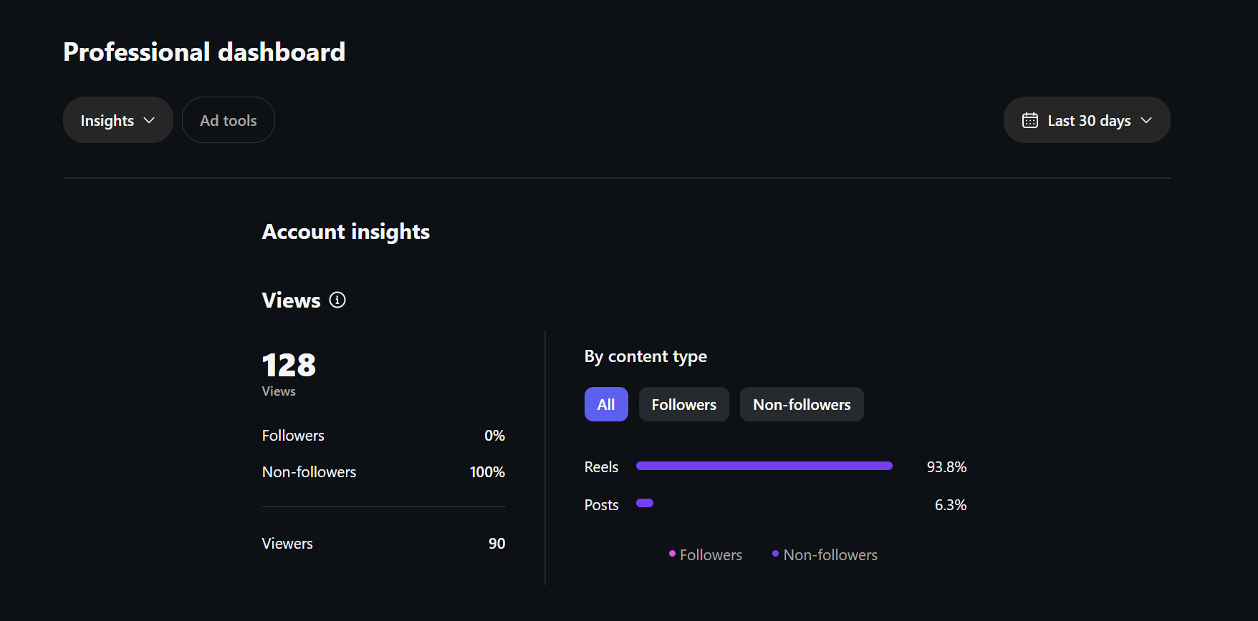
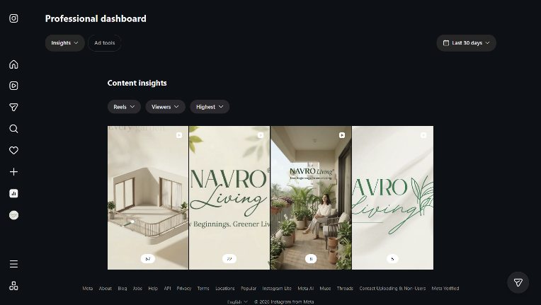
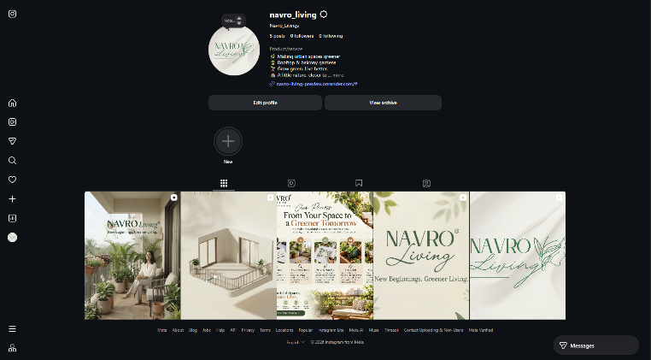
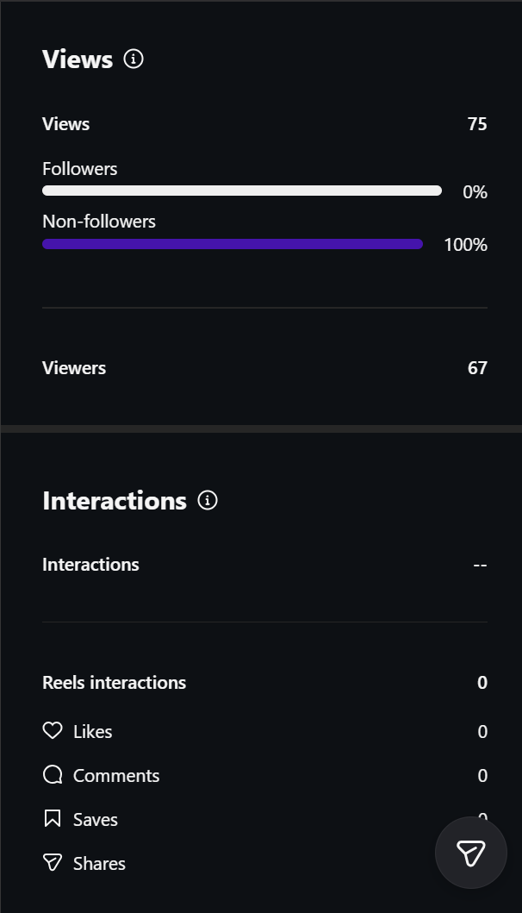

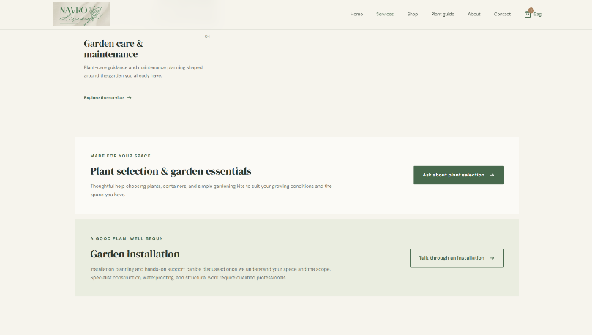
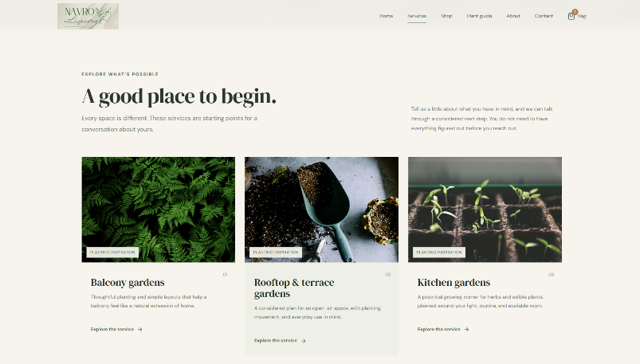
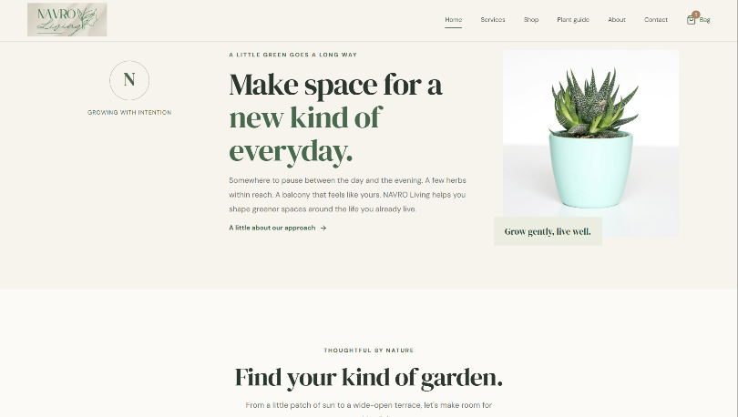
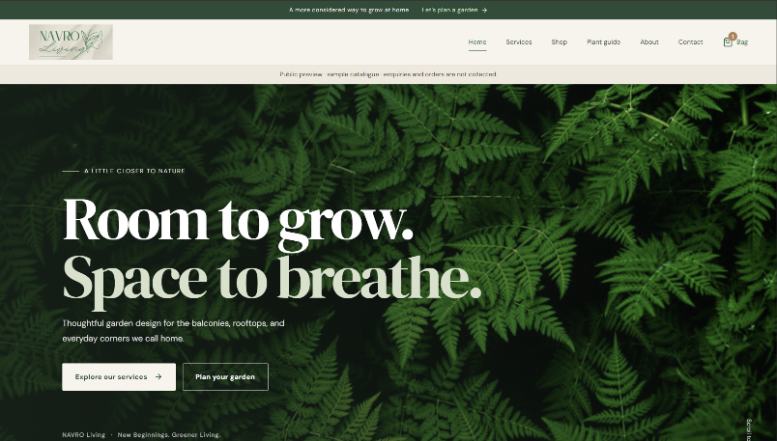
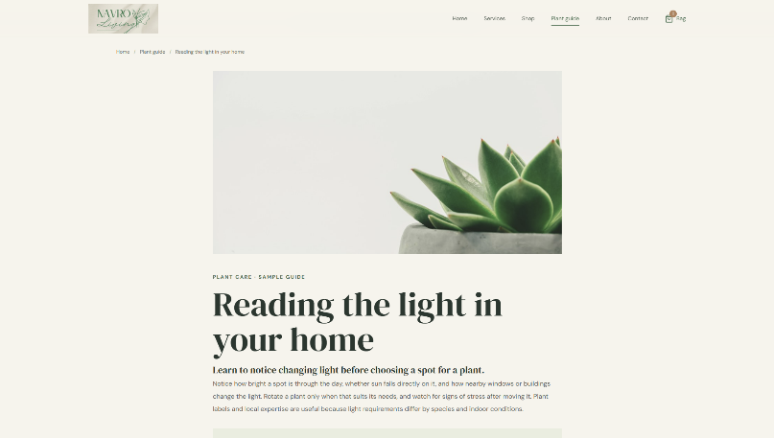
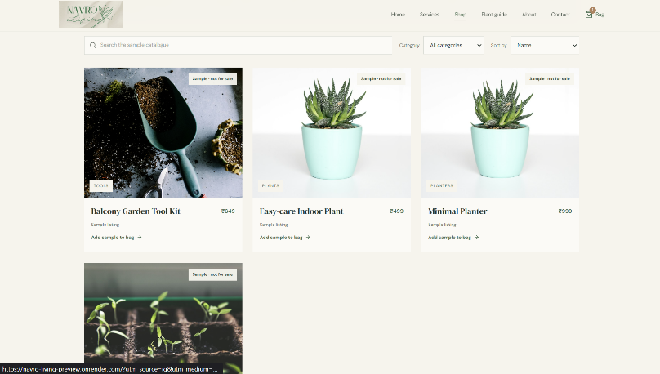
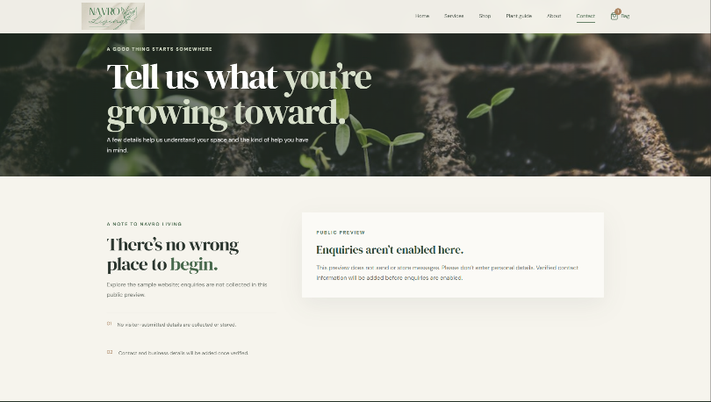
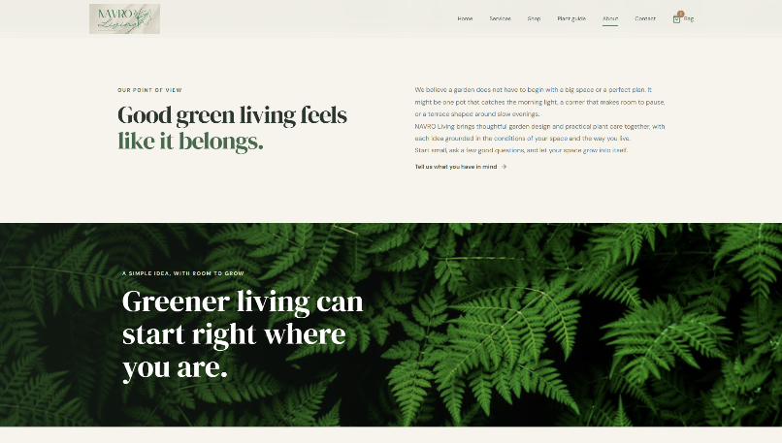

7. What I Learned
I learned that digital marketing can help a new business build brand awareness at a relatively low cost. Instagram Reels can introduce NAVRO Living to people who do not follow the account. AI tools can support content creation, while Instagram Insights can help identify effective content and areas requiring improvement.

B.2 Conclusion
Through this experiment, I learned how digital marketing and AI tools can be used to promote NAVRO Living. I identified the target customers, selected suitable digital platforms, created promotional content, and analysed Instagram performance. The results showed that Reels generated most of the account's views, but further efforts are required to increase engagement, followers, and customer enquiries. This experiment helped me understand how digital marketing can support brand awareness and business growth.
B.3 Question of Curiosity
Questions for Students:
- Which digital platform is most suitable for promoting your business idea, and why?
Instagram is the most suitable platform for NAVRO Living because garden designs and space transformations can be presented visually through Reels, posts, and stories.

- How can AI help you promote your product/service more effectively?
AI can generate captions, advertisements, video ideas, content calendars, and customer survey questions. It can save time and help maintain consistent promotional content.

- Which type of content do you think will attract your target customers the most?
Before-and-after garden transformations, balcony makeover videos, small-space gardening ideas, and plant-care tips are likely to attract potential customers.

- How would you improve your digital marketing strategy based on customer feedback?
I would study Instagram Insights, create more engaging Reels, improve captions and calls to action, post consistently, and collect direct feedback through surveys and customer enquiries.

- If you had a limited marketing budget, how would you promote your business using free digital tools?
I would use Instagram Reels, WhatsApp Business, Canva, and ChatGPT to create and share promotional content. I would also encourage customer referrals, collaborate with local gardening communities, and use customer testimonials with permission.

